1. **URL -** <http://uat.wellogo.in/Eicore.design.v2/employee.html>

Page is not properly responsive.

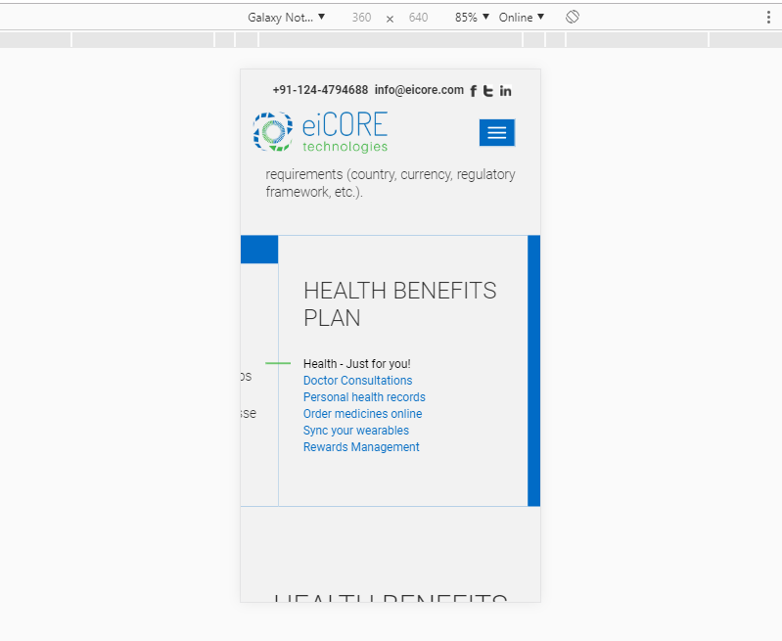

1. **URL -** http://uat.wellogo.in/Eicore.design.v2/index.html

Company number and e-mail id is not visible in footer.

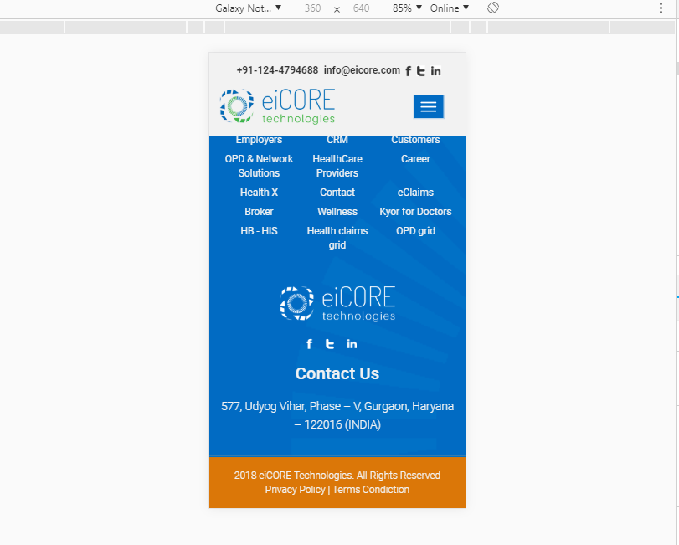

1. **URL** - <http://uat.wellogo.in/Eicore.design.v2/opd-network.html>

Banner background image is not visible properly.

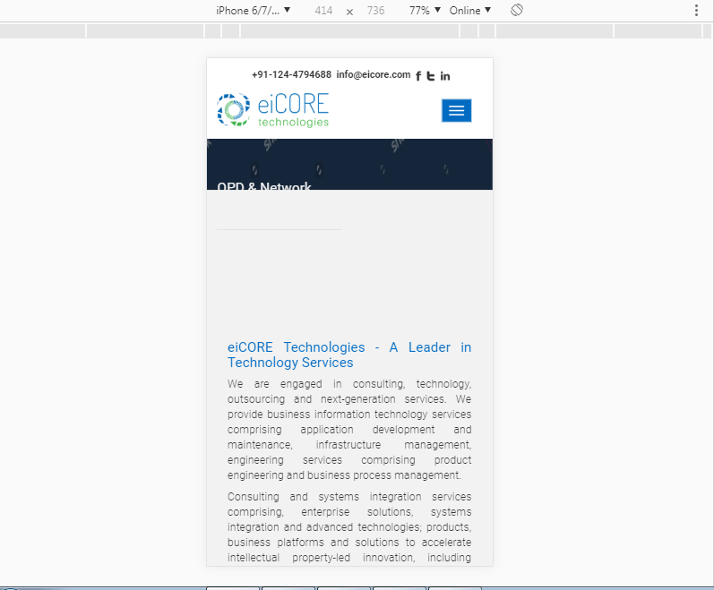

1. **URL-** <http://uat.wellogo.in/Eicore.design.v2/e-claims.html>

Banner image is not displayed.

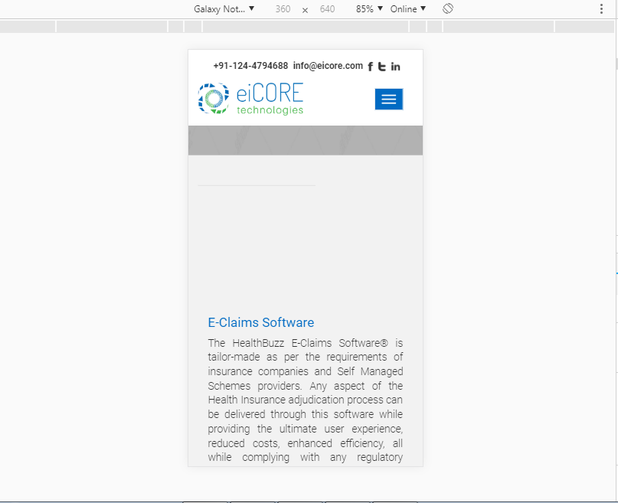

1. **URL-** <http://uat.wellogo.in/Eicore.design.v2/kyor-for-doctors.html>

Background banner image is not proper responsive.

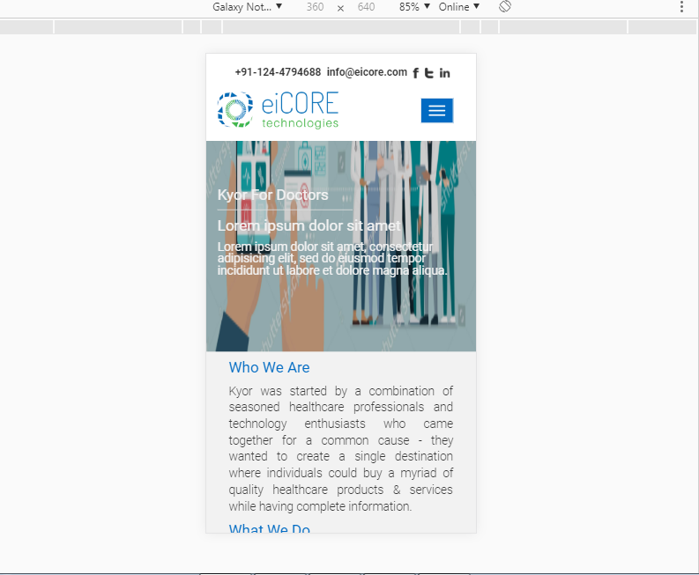

1. **Landscape view-** Banner text is not properly visible. It’s hiding by header.

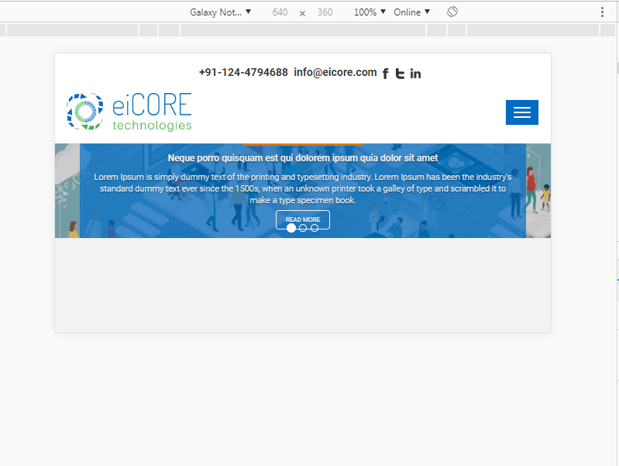

1. Text is not properly visible.

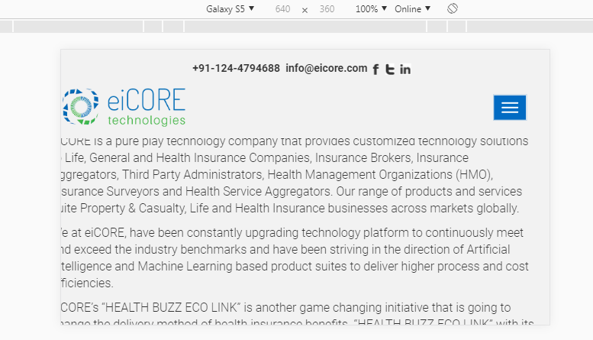

1. **Broken links –**

<http://uat.wellogo.in/Eicore.design.v2/fonts/glyphicons-halflings-regular.woff2>

<http://uat.wellogo.in/Eicore.design.v2/fonts/fontawesome-webfont.woff2?v=4.7.0>

1. **Links are not having webpage.**

